**New Executive Director presents Cedefop to new European Parliament EMPL Committee**

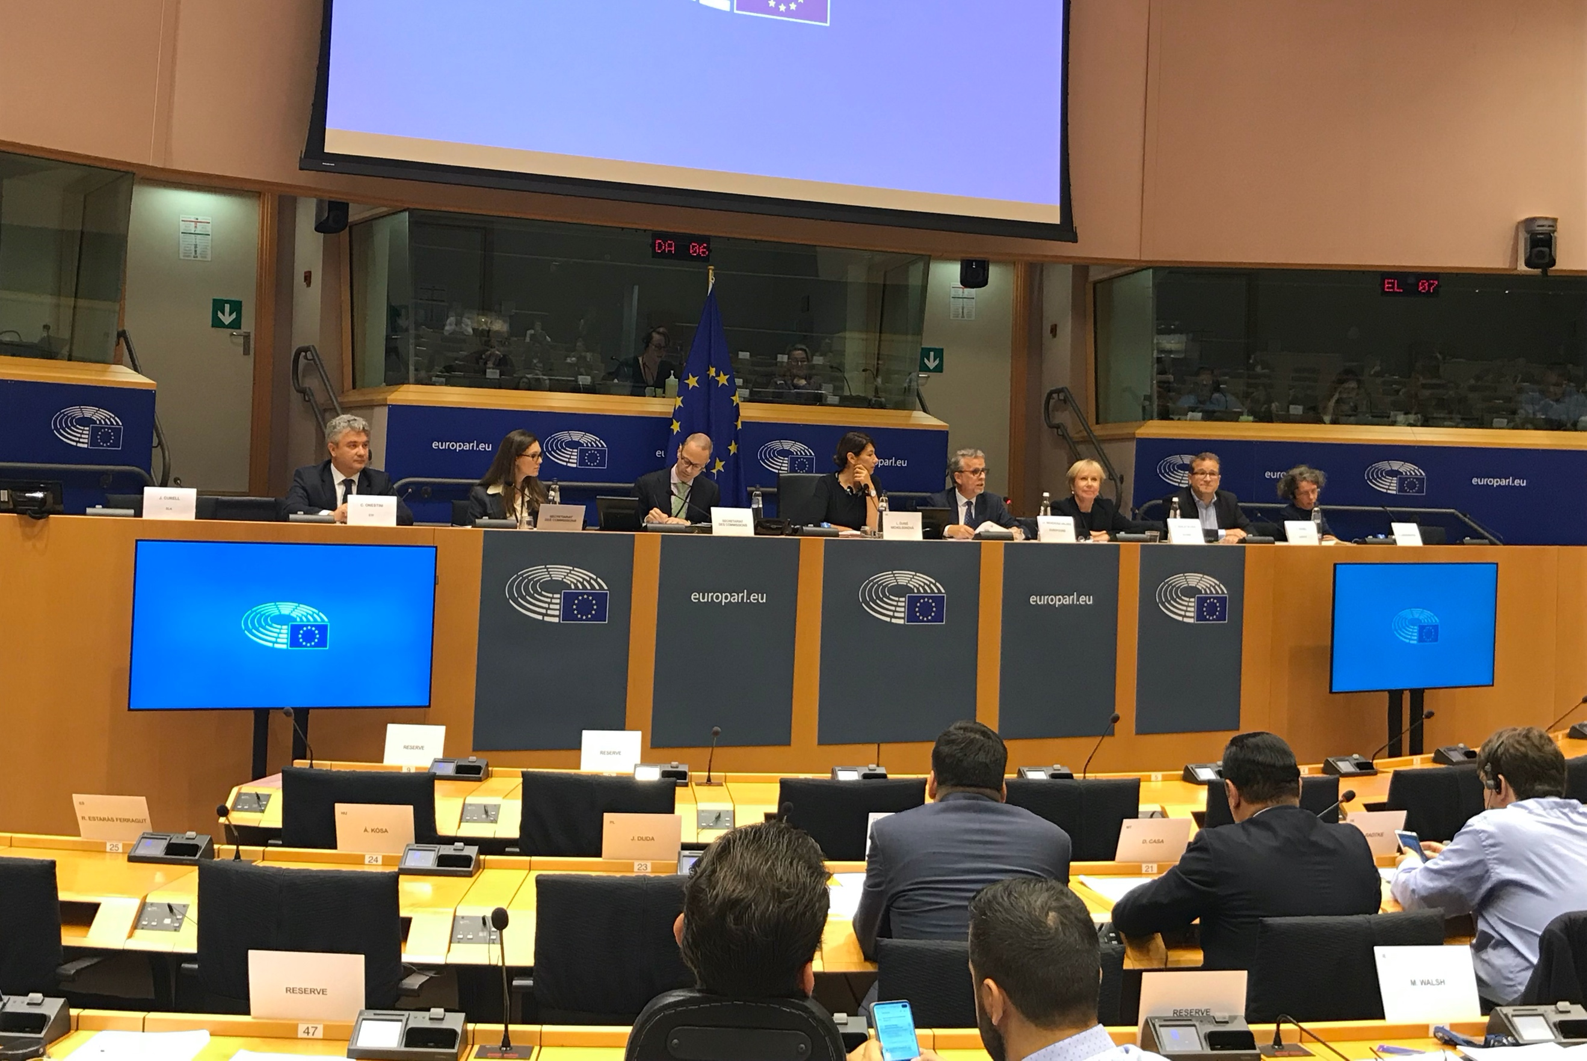

**Image copyright:**

© Cedefop, 2019/Cosmin Roman

**Cedefop Executive Director Jürgen Siebel**[**presented**](https://www.cedefop.europa.eu/en/publications-and-resources/videos/cedefop-executive-director-european-parliament-empl-committee)**the agency’s work and priorities for 2020-22 to the members of the European Parliament’s Committee on Employment and Social Affairs (EMPL), on 24 September in Brussels.**

Mr Siebel spoke along with his fellow directors of EU agencies Eurofound, the European Training Foundation (ETF), EU-OSHA and the newly established European Labour Authority (ELA). They also replied to questions from committee members.

Outlining Cedefop’s current role, Mr Siebel said: ‘We promote the understanding of vocational education and training (VET) systems, we provide support to and shape the Copenhagen process via the education and training 2020 scheme, we have been shaping the VET policy agenda, we have supported its implementation and we are monitoring progress. Since 2007, we have also assumed a stronger policy supporting role and this year, with our revised Founding Regulation that is now in force, we have also formally recognised and included activities that go a bit beyond VET and that had been ongoing for quite some time. In this case, it’s all about labour market and skills analysis and qualifications.’

He went on: ‘Cedefop has become a recognised centre of quantitative and qualitative policy-relevant research on VET for young people and adults, skills and qualifications. Our analysis of current and future relations between jobs, skills and qualifications provides policy-makers with the opportunity to modernise their VET systems. Cedefop’s research on qualifications has helped to develop some common transparency tools based on the outcomes of learning. We have supported VET reform across Europe with those tools and contributed to a different perception of VET. This has also reinforced Cedefop’s role at the interface between education and training and the labour market – an area not covered by any other EU organisation.’

**Priorities going forward**

Mr Siebel referred to Cedefop’s multiannual programme that is defined ‘by our vision, our values, the multiannual objectives that are set for us,’ and presented the agency’s three strategic areas of operation entrusted with fulfilling these objectives: shaping, valuing and informing VET.

After going through the various activities of the operational areas, he showed how Cedefop communicates their results in an impactful way.

He then talked about VET’s changing nature and how Cedefop, through its relevant project, ‘would like to facilitate learning from the past and good practices, by increasing our understanding of the implications of different choices for the future.’

**Partnership with stakeholders**

Replying to questions from MEPs on formalising training and making it more comparable across Member States, Mr Siebel said that ‘We are doing this at Cedefop. We are offering practice-sharing across borders and policy learning, but we are doing it more in a way of helping rather than instructing. I think it must be a partnership between the national stakeholders and Cedefop, and we have some very good examples.’

He noted that he sees VET ‘not as a ceiling but as the floor for a career; and we have to make sure in all Member States that education systems are permeable.’

When asked about combining theoretical with practical learning, he argued that ‘VET is actually the model that does that, because it always combines the theoretical part with the applied learning opportunities, be it in the labs of the vocational schools or in the employers if it’s work-based learning. There is a lot of opportunity, much more than in the academic system to acquire applied learning; that’s why one of our scenarios for future VET also includes extending the idea of this combination into higher education, called higher VET.’

Mr Siebel pointed out that Cedefop systematically engages with civil society groups, ‘one example being the European vocational skills week, where we are involved as a partner of the European Commission and the entire VET community is represented; things are shared, joint projects discussed.’

As for the ELA’s added value to other EU agencies, he replied that ‘it is early to say; in our sphere, in VET, there is a lot of talk about apprenticeship mobility; people should be able to do what students of academia can do under Erasmus+, but restrictive national regulations often make that difficult.’

You can watch Mr Siebel’s presentation [**here**](https://www.cedefop.europa.eu/en/publications-and-resources/videos/cedefop-executive-director-european-parliament-empl-committee) and the entire EMPL Committee hearing at the [**European Parliament website**](https://www.europarl.europa.eu/ep-live/en/committees/video?event=20190924-0900-COMMITTEE-EMPL).